**SZK2400 taphole drilling machine**

**Operation manual**

Beijing shouzhi engineering&technology co.,ltd

**Content**

1. Equipment composition
2. Main performance and parameter
3. Structure and working principle
4. Site installation and test
5. Drilling machine operation
6. Maintain and repair
7. Main standard part list
8. Quick wear part list

1.Equipment composition

SZK2400型液压开口机由钻冲小车、送进机构、回转机构、倾角机构和液压站组成。

SZK2400 hydraulic drilling machine including punching device, feeding device, rotary device, inclination device and hydraulic station.

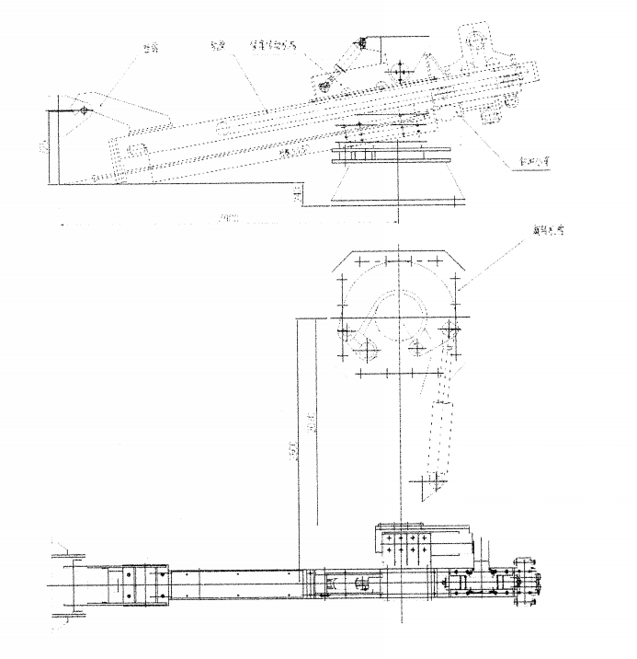

SZK2400 hydraulic drilling machine [structural](C:/Program%20Files%20(x86)/Youdao/Dict/8.5.3.0/resultui/html/index.html#/javascript:;) [diagram](C:/Program%20Files%20(x86)/Youdao/Dict/8.5.3.0/resultui/html/index.html#/javascript:;)

1. Main performance and parameter

|  |  |
| --- | --- |
| **Punching device** | |
| Drill bit diameter mm | 50~65 |
| Drill bit speed r/min | ~300 |
| Drilling inclination ° | 10°（8~16°adjustable ） |
| Drilling depth mm | ~2400 |
| Impact energy J | 350 |
| Impact hertz Hz | 40~50 |
| Operation oil pressure MPa | 13 |
| Quantity of flow L/min | Drill 70, impact 90 |
| **Rotary device** | |
| rotation angle | 150° |
| Rotation time sec | 12~15 |
| Operation oil pressure MPa | 13 |
| Quantity of flow L/min | 40~50 |
| **Feeding device** | |
| Feeding speed m/sec | 0.025~0.05 |
| Withdraw speed sec | 1 |
| Operation oil pressure MPa | 13 |
| Quantity of flow L/min | Feeding 4L/min withdraw 80L/min |
| **Inclination drive device** | |
| Operation oil pressure MPa | 8 |
| Quantity of flow L/min | 15 |

3. Structure and working principle

3.1 Drilling mechanism

The drilling trolley is equipped with a hydraulic rock drill, which consists of a cycloidal motor rotary drill mechanism, an impactor and a side air supply device. The cycloidal motor rotates the drill rod, The impactor makes the drill rod produce high-frequency linear impacting, and the compressed air reaches the head of the drill by the side air supply device, and then washes the gun mud from the vent hole to make the hole clean and ensure the smooth flow of melted iron. Oil motor and impactor supply pressure oil separately. Operated by respective manual reversing valves. Drilling and impacting can be done simultaneously or separately.

3.2 Feeding mechanism

The hydraulic rock drill is fastened to the trolley, and the trolley is equipped with four wheels, Walk along the lower edge of the rail beam channel steel. The feed motor, which relies on the upper drive unit of the rail beam tail, is pulled by the chain to make the drilling trolley walk. By adjusting the flow rate of oil supply to the feed motor, the drilling trolley can realize slow forward and fast backward. A tension screw is installed on the guide sprocket wheel at the tail of the rail beam. The tension screw can be adjusted to adjust the tension degree of the traction chain.

The upper part of the front end of the rail beam is provided with a hook. When the rotating arm of the taphole drilling machine is turned to the opening position, the hook at the front end of the rail beam is connected with the hook support on the blast furnace shell by the swinging mechanism, and is pressed against the hook support. When the drilling trolley is working,the hook at the front end of the rail beam always presses the hook support on the blast furnace shell, so that the rail beam does not sway when the drill rod is drilled and punched.

3.3 Rotary mechanism

The rotating arm of the taphole drilling machine is transformed from the linear motion of the cylinder to the rotation of the rotating arm.

3.4 Inclinometer drive mechanism

Inclinometer drive mechanism is connected to rotary mechanism and feeding mechanism of taphole drilling machine and ensure the taphole drilling machine is a device of adjusting the drill hole angle of drill rod when in working position, the working procedure is that when the rotary mechanism reaches the working position, the inclinometer transmission cylinder head port feeding the oil to the opening position, and the hook hooks the hook support on the blast furnace shell, the rotating arm stops rotating. When the taphole drilling machine during the drilling and punching process, the hooks on the rail beam can always pull the hook support on the blast furnace shell to ensure the smooth progress of the whole working process.

After the taphole drill is completed, the oil motor of the feeding mechanism makes the drilling trolley return quickly. After the drill rod exits the taphole, oil is supplied to rod port of the inclinometer transmission cylinder to make the hook on the rail beam disengage from the hook support. Then the hydraulic motor of the reverse rotation rotary arm makes the rotary arm rotate to the stopping position to complete one time taphole motion.By adjusting the throttle valve of the hydraulic system, the oil supply of the oil motor can be adjusted, and the rotary speed of the rotary arm can be adjusted. Complete one time taphole motion.

3.5 Hydraulic system

The hydraulic system of the taphole drilling machine and mud gun and slag plugging machine are configured according to the scheme of one room, one station and two valve stands. The blast furnace has one taphole. The taphole is equipped with 1 set taphole drilling machine and 1 set mud gun, sharing one hydraulic pump station. The swinging mechanism cylinder and the drilling motor and the rotary cylinder of the taphole drilling machine are supplied by one oil pump, the feeding motor of the drilling trolley and the impactor of the rock drilling machine are supplied by another oil pump, and the oil circuit of the hydraulic system ensures the manual reversing valve in the middle position, the oil pump is in the unloaded state.

Each pumping station is equipped with a circulating filter device that filters the hydraulic oil in the oil tank through a circulating filter oil pump. Ensure the cleanliness of the oil.

Working medium is N46 anti-wear hydraulic oil.

4. Site installation and commissioning

Before the taphole drilling machine is installed in the blast furnace tapping field, check whether the taphole drilling machine parts are complete and the position of the anchor bolts is consistent with the general drawing of the taphole drilling machine.

The installation sequence in front of the furnace is: rotary mechanism - Inclinometer drive mechanism - rail beam - drilling trolley - the nozzle on the taphole drilling machine body and connecting the pipeline on the body with the pipeline from the pump station and the valve platform, Re-weld the hook support on the blast furnace shell during commissioning.

The order of debugging is the first hydraulic station and the rear taphole drilling machine body. The main content of the hydraulic station commissioning is the working pressure of each system. The flow rate of each system is adjusted by the throttle valve to achieve the required moving speed of each mechanism. The rotary time of the taphole drilling machine is 12~15sec, and the forward speed of the drilling trolley is about one minute from the start of drilling to the opening of the taphole. The speed of the quick return of the drilling trolley is preferably 1m~1.2m/sec.

The position of the hook support on the blast furnace shell should be determined during on-site commissioning. The principle is that when the taphole drilling machine is rotated to the opening position, the hook at the front end of the rail beam is hooked on the hook support on the blast furnace shell, The damper on the rotary structure is in close contact with the limit stopper bolt head and has a small amount of compression (the limit bolt can be adjusted). According to this principle, the hook support height is determined and welded to the blast furnace shell.

After the installation, if the drill bit fails to align with the center of the taphole, the upper and lower positions of the drill bit can be adjusted by adjusting the thickness of the gasket between the hook and the rail beam to achieve the taphole angle is 6°~22°.

Special warning: install all the oil pipes (seamless pipe, steel wire braided hose) connected to all taphole drilling machines to be cleaned and high-pressure air purged. At the same time, the steel wire braided hose is connected to the same circuit to form a cycle cleaning before connecting the actuators. Otherwise, It will cause serious damage to the hydraulic system and the actuators of the taphole drilling machine, resulting in the taphole drilling machine not working properly.

5.The taphole drilling machine operation

Operators should read this manual before taking up the post, to understand and be familiar with the structure, operation principle and operation essentials of the taphole drilling machine. The taphole drilling machine is a temporary working equipment. When the taphole drilling machine is in the stopping position, the oil pump of the hydraulic station should be in the pump stopping state. Starting the oil pump before each operation of the taphole drilling machine, and stopping the pump in time after each operation. The start and stop buttons are on the electric cabinet in the operation room.

Each action of the taphole drilling machine is controlled by a manual reversing valve on the operating valve table and a ball valve on the pneumatic distributor, When the drilling trolley advances, the oil feeding motor, the drilling motor and the impactor must be operated. The operator cannot operate the three handles at the same time. Therefore, the oil feeding motor adopts the manual directional valve of the steel ball positioning, as long as the operator puts the handle in the forward (or reverse) position, the operator releases the handle and the valve element does not automatically return to the middle position. The operator must pull the handle again before returning to the middle position. In addition to the oil feeding motor, the other manual reversing valves are spring reset.

The normal operation sequence is: starting the oil pump - the taphole drill machine rotates to the opening position, at the same time the swing cylinder head port feed the oil, forcing the rail beam to tilt downward until the hook presses the hook support tightly- drilling trolley forward - drilling and punching. When the taphole is opened, the drilling trolley will return quickly. It should be noted that after the drill rod and the drill bit are all out of the taphole, the swing cylinder rod port feeding oil, forcing the rail beam to be lifted, and after the hook is separated from the hook support, the rotary arm will rotate in reverse until the stopping position.

When the taphole can not opened at one time, the drill pipe turns bend and becomes red. When it needs to be replaced, the drill rod should be withdrawn first, and the drilling trolley should be retracted to the final position. The feeding mechanism swing and the rotary arm is turned to a convenient position for replacing the drill rod. Continue to open the taphole after replacing the drill rod.

If the accumulation of slag blocks on both sides of the main melted iron ditch is too high, it will hinder the rotary of the taphole drilling machine and the swing of the hydraulic pipelines. The operator should clean the slag blocks on both sides of the main melted iron ditch in time, so as not to hinder the rotary of the taphole drilling machine and the swing of the movable joint of the hydraulic hard pipe.

Special warning: After the taphole drilling is completed, when the trolley retreats to the non-working position, the rail beam hook must be disengaged from the hook support before the big arm can be rotated. Otherwise, the long axis of the swing mechanism is easily deformed.

6. Maintenance and overhaul

The reason of the hydraulic system fault is caused by the uncleaning of the hydraulic oil. Maintaining the cleanliness of the hydraulic system hydraulic oil is one of the main contents of daily maintenance. The hydraulic station is equipped with circulating filtration system. The circulating filter system should be frequently used to check the filter element, and the cleanliness of the hydraulic oil should be checked once a month, which should reach NAS10~11 grade. Care should be taken not to allow dust and dirt to enter the hydraulic system when overhaul the hydraulic system.

If there is leakage in the hydraulic pipeline of the taphole drilling machine, find out the cause and take measures in time.

The lubrication of all parts of the taphole drilling machine is made of 3# lithium-based grease. The brand ZL-3 is manually oil injection. The oil is injected once a day, and the replenishment amount of each point is about 5~10cc.

The taphole drilling machine should be regularly inspected, processed and recorded according to the contents of the items given in the list below.

|  |  |  |  |
| --- | --- | --- | --- |
| SN. | Phenomenon | Reason | Handle |
| 1 | Oil pump noise increases, abnormal vibration or pressure fluctuations | Oil pump damage | Change the pump and pay attention to whether the oil is clean |
| 2 | The oil appears milky white, or black, smelly. | Oil contains excess water, or oxidative deterioration | Change the oil and find the cause |
| 3 | Oil temperature exceeds 65°C | System working time is too long or pump efficiency is reduced | Pay attention to the working time or change the pump |
| 4 | The reversing valve is stuck | Damaged valve element or dirt in the valve | Change the oil and find the cause |
| 5 | Oil leakage | Damaged seal or loose thread | Replace seals or tighten threads |

7. Standard Piece list

|  |  |  |  |  |
| --- | --- | --- | --- | --- |
| Sr | Name | Rules & Type No | QTY | Note |
| 1 | Cone sub axis bearing | 32060 | 1 |  |
| 2 | Cone sub axis bearing | 32056 | 1 |  |
| 3 | Roller Chain | 20A-1×308 | 1 |  |
| 4 | Oil Motor | 6Kseries motor  490ml/r | 1 | Moment key shaft |
| 5 | Off section axis load | GEG80ES-2RS | 1 |  |
| 6 | Off section axis load | GEG90ES-2RS | 1 |  |
| 7 | Off section shaft load | GEG100ES-2RS | 2 |  |
| 8 | Off section axis load | GE60ES-2RS | 2 | Back to cylinder |

8. Quick wear parts List

|  |  |  |  |
| --- | --- | --- | --- |
| Sr no | Name | Rules & TypeNo | Qty |
| 1 | Disc shaped spring reed | SZK24-1-1-2-3 | 25 |
| 2 | Shaft set | SZK24-1-1-3-5 | 2 |
| 3 | Shaft set (1) | SZK24-1-1-5-3 | 4 |
| 4 | Shaft set (2) | SZK24-1-1-5-6 | 2 |
| 5 | Direct Set | SZK24-1-1-5-13 | 2 |
| 6 | Drill Rod | Dia 38 L=3500 | 1 |
| 7 | 1 drill bit 60 | TP 10-8938 | 1 |
| 8 | Connected sets | LJ38-5518 | 1 |